Copy B - To Be Filed With Employee’s FEDERAL Tax Return 41-0852411 OMB No.1545-0008  a Employee’s soc. sec. no. 230-57-6599 1 Wages, tips, other compensation. 27019.44 2 Federal income tax withheld 2592.56  3 Social security wages 27019.44 4 Social security tax withheld 1675.21  b Employer ID number  59-2552462  5 Medicare wages and tips 27019.44 6 Medicare tax withheld 391.78  c Employer’s name, address, ZIP code  CoAdvantage Resources 16, Inc.  3350 Buschwood Park Dr #200  Tampa, FL 33618  d Control number  e Employee’s name, address, and ZIP code TARA K SCHNEPP 7453 SUGAR BEND DR ORLANDO, FL 32819 Suff.  7 Social security tips 0.00 8 Allocated tips 0.00 9  10 Dependent care benefits 11 Nonqualified plans 12a Code See inst. for box 12  13 Statutory employee 14 Other 12b Code  Retirement plan 12c Code  Third-party sick pay 12d Code  15 State Employer’s state I.D. number 16 State wages, tips, etc. 17 State income tax  18 Local wages, tips, etc. 19 Local income tax 20 Locality name |  | Copy 2 - To Be Filed With Employee’s State, City, or Local Tax Return 41-0852411 OMB No.1545-0008  a Employee’s soc. sec. no. 230-57-6599 1 Wages, tips, other compensation. 27019.44 2 Federal income tax withheld 2592.56  3 Social security wages 27019.44 4 Social security tax withheld 1675.21  b Employer ID number (EIN)  59-2552462  5 Medicare wages and tips 27019.44 6 Medicare tax withheld 391.78  c Employer’s name, address, and ZIP code  CoAdvantage Resources 16, Inc.  3350 Buschwood Park Dr #200  Tampa, FL 33618  d Control number  e Employee’s name, address, and ZIP code TARA K SCHNEPP 7453 SUGAR BEND DR ORLANDO, FL 32819 Suff.  7 Social security tips 0.00 8 Allocated tips 0.00 9  10 Dependent care benefits 11 Nonqualified plans 12a Code See inst. for box 12  13 Statutory employee 14 Other 12b Code  Retirement plan 12c Code  Third-party sick pay 12d Code  15 State Employer’s state I.D. number 16 State wages, tips, etc. 17 State income tax  18 Local wages, tips, etc. 19 Local income tax 20 Locality name
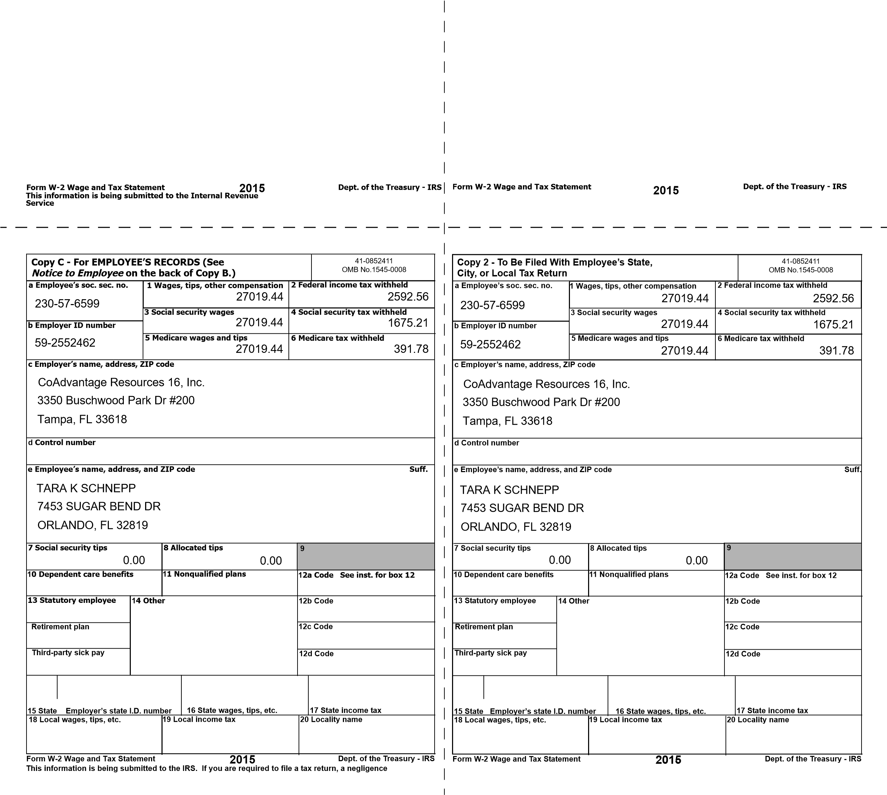
penalty or other sanction may be imposed on you if this income is taxable and you fail to report it.
Notice to Employee
Do you have to file? Refer to the Form 1040 Instructions to determine if you are required to file a tax return. Even if you do not have to file a tax return, you may be eligible for a refund if box 2 shows an amount or if you are eligible for any credit.
Earned income credit (EIC).You may be able to take the EIC for 2015 if your adjusted gross income
(AGI) is less than a certain amount. The amount of the credit is based on income and family size. Workers without children could qualify for a smaller credit. You and any qualifying children must have valid social security numbers (SSNs). You cannot take the EIC if your investment income is more than the specified amount for 2015 or if income is earned for services provided while you were an inmate at a penal institution. For 2015 income limits and more information, visit www.irs.gov/eitc. Also see Pub. 596, Earned Income Credit. Any EIC that is more than your tax liability is refunded to you, but only if you file a tax return.
Clergy and religious workers. If you are not subject to social security and Medicare taxes, see Pub. 517, Social Security and Other Information for Members of the Clergy and Religious Workers.
Corrections. If your name, SSN, or address is incorrect, correct Copies B, C, and 2 and ask your employer to correct your employment record. Be sure to ask the employer to file Form W-2c, Corrected Wage and Tax Statement, with the Social Security Administration (SSA) to correct any name, SSN, or money amount error reported to the SSA on Form W-2. Be sure to get your copies of Form W-2c from your employer for all corrections made so you may file them with your tax return. If your name and SSN are correct but are not the same as shown on your social security card, you should ask for a new card that displays your correct name at any SSA office or by calling 1-800-772-1213. You also may visit the SSA at www.socialsecurity.gov.
Cost of employer-sponsored health coverage (if such cost is provided by the employer). The reporting in box 12, using code DD, of the cost of employer-sponsored health coverage is for your information only. The amount reported with code DD is not taxable.
Credit for excess taxes. If you had more than one employer in 2015 and more than $7,347 in social security and/or Tier 1 railroad retirement (RRTA) taxes were withheld, you may be able to claim a credit for the excess against your federal income tax. If you had more than one railroad employer and more than $4,321.80 in Tier 2 RRTA tax was withheld, you also may be able to claim a credit. See your Form 1040 or Form 1040A instructions and Pub. 505, Tax Withholding and Estimated Tax.
(Also see Instructions for Employee, below.

Instructions for Employee
Box 1. Enter this amount on the wages line of your tax return. Box 2. Enter this amount on the federal income tax withheldline of your taxreturn.
Box 5. You may be required to report this amount on Form 8959, AdditionalMedicare Tax. See Form 1040 instructions to determine if you are required to complete Form 8959. Box 6. This amount includes the 1.45% Medicare Tax withheld on all Medicare wages and tips shown in Box 5, as well as the 0.9% Additional Medicare Tax on any of those Medicare wages and tips above $200,000.
Box 8. This amount is not included in boxes 1, 3, 5, or 7. For information on how to report tips on your tax return, see your Form 1040 instructions. You must file Form 4137, Social Security and Medicare Tax on Unreported Tip Income, with your income tax return to report at least the allocated tip amount unless you can prove that you received a smaller amount. If you have records that show the actual amount of tips you received, report that amount even if it is more or less than the allocated tips. On Form 4137 you will calculate the Social Security and Medicare tax owed on the allocated tips shown on your Form(s) W-2 that you must report as income and on other tips you did not report to your employer. By filing Form 4137, your social security tips will be credited to your social security record (used to figure your benefits).
Box 10. This amount includes the total dependent care benefits that your employer paid to you or incurred on your behalf (including amounts from a section 125 (cafeteria) plan). Any amount over $5,000 is also included in box 1. Complete Form 2441, Child and Dependent Care Expenses, to compute any taxable and nontaxable amounts.
Box 11. This amount is (a) reported in box 1 if it is a distribution made to you from a nonqualified deferred compensation or nongovernmental section 457(b) plan or (b) included in box 3 and/or 5 if it is a prior year deferral under a nonqualified or section 457(b) plan that became taxable for Social Security and Medicare taxes this year because there is no longer a substantial risk of forfeiture of your right to the deferred amount. This box should not be used if you had a deferral and a distribution in the same calendar year. If you made a
deferral and received a distribution in the same calendar year, and you are or will be age 62 by the end of the calendar year, your employer should file Form SSA-131, Employer Report of Special Wage Payments, with the Social Security Administration and give you a copy.
Box 12. The following list explains the codes shown in box 12. You may need this information to complete your tax return. Elective deferrals (codes D, E, F, and S) and designated Roth contributions (codes AA, BB, and EE) under all plans are generally limited to a total of $18,000 ($12,500 if you only have SIMPLE plans; $21,000 for section 403(b) plans if you qualify for the 15-year rule explained in Pub. 571). Deferrals under code G are limited to $18,000. Deferrals under code H are limited to $7,000. However, if you were at least age 50 in 2015, your employer may have allowed an additional deferral of up to $6,000 ($3,000 for section 401(k)(11) and 408(p) SIMPLE plans). This additional deferral amount is not subject to the overall limit on elective deferrals. For code G, the limit on elective deferrals may be higher for the last 3 years before you reach retirement age. Contact your plan administrator for more information. Amounts in excess of the overall elective deferral limit must be included in income. See the “Wages, Salaries, Tips, etc.” line instructions for Form 1040.
Note. If a year follows code D through H, S, Y, AA, BB, or EE, you made a make-up pension contribution for a prior year(s) when you were in military service. To figure whether you made excess deferrals, consider these amounts for the year shown, not the current year. If no year is shown, the contributions are for the current year.
A—Uncollected social security or RRTA tax on tips. Include this tax on Form 1040. See “Other Taxes” in the Form 1040 instructions.
B—Uncollected Medicare tax on tips. Include this tax on Form 1040. See “Other Taxes” in the Form 1040 instructions. C—Taxable cost of group-term life insurance over $50,000 (included in boxes 1, 3 (up to social security wage base), and 5)
D—Elective deferrals to a section 401(k) cash or deferred arrangement. Also includes deferrals under a SIMPLE retirement account that is part of a section 401(k) arrangement.
E—Elective deferrals under a section 403(b) salary reduction agreement.
F—Elective deferrals under a section 408(k)(6) salary reduction SEP.
G—Elective deferrals and employer contributions (including nonelective deferrals) to a section 457(b) deferred compensation plan.
H—Elective deferrals to a section 501(c)(18)(D) tax-exempt organization plan. See “Adjusted Gross Income” in the Form 1040 instructions for how to deduct. J—Nontaxable sick pay (information only, not included in boxes 1, 3, or 5).
K—20% excise tax on excess golden parachute payments. See “Other Taxes” in the Form 1040 instructions. L—Substantiated employee business expense reimbursements (nontaxable).
M—Uncollected social security or RRTA tax on taxable cost of group-term life insurance over $50,000 (former employees only).
See “Other Taxes” in the Form 1040 instructions. N—Uncollected Medicare tax on taxable cost of group-term life insurance over $50,000 (former employees only). See “Other Taxes” in the Form 1040 instructions. P—Excludable moving expense reimbursements paid directly to employee (not included in boxes 1, 3, or 5). Q—Nontaxable combat pay. See the instructions for Form 1040 or Form 1040A for details on reporting this amount.
R—Employer contributions to your Archer MSA. Report on Form
8853, Archer MSAs and Long-Term Care Insurance Contracts. S— Employee salary reduction contributions under a section 408(p) SIMPLE plan (not included in box 1).
T—Adoption benefits (not included in box 1). Complete Form 8839, Qualified Adoption Expensesto compute any taxable and nontaxable amounts.
V—Income from exercise of nonstatutory stock option(s) (included in boxes 1, 3 (up to Social Security wage base), and 5). See Pub. 525 and instructions for Schedule D (Form 1040) for reporting requirements.
W—Employer contributions (including amounts the employee elected to contribute using a section 125 (cafeteria) plan) to your health savings account. Report on Form 8889, Health Savings Accounts (HSAs).
Y—Deferrals under a section 409A nonqualified deferred compensation plan.
Z—Income under a nonqualified deferred compensation plan that fails to satisfy section 409A. This amount is also included in box 1. It is subject to an additional 20% tax plus interest. See “Other Taxes” in the Form 1040 instructions.
AA—Designated Roth contributions under a section 401(k) plan.
BB—Designated Roth contributions under a section 403(b) plan. DD— Cost of employer-sponsored health coverage. The amount reported with Code DD is not taxable. EE—Designated Roth contributions under a governmental section 457(b) plan. This amount does not apply to contributions under a tax-exempt organization section 457(b) plan.
Box 13. If the “Retirement plan” box is checked, special limits may apply to the amount of traditional IRA contributions you may deduct. See Pub. 590, Individual Retirement Arrangements (IRAs). Box 14. Employers may use this box to report information such as state disability insurance taxes withheld, union dues, uniform payments, health insurance premiums deducted, nontaxable income, educational assistance payments, or a member of the clergy's parsonage allowance and utilities. Railroad employers use this box to report railroad retirement (RRTA) compensation, Tier 1 tax, Tier 2 tax, Medicare tax and Additional Medicare Tax. Include tips reported by the employee to the employer in railroad retirement (RRTA) compensation.
Note. Keep Copy C of Form W-2 for at least 3 years after the due date for filing your income tax return. However, to help protect your Social Security benefits, keep Copy C until you begin receiving Social Security benefits, just in case there is a question about your work record and/or earnings in a particular year.

